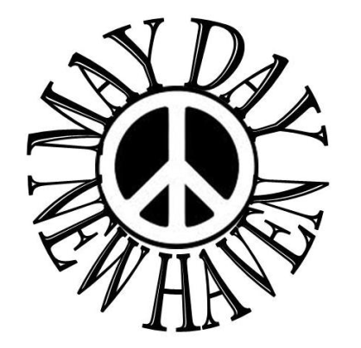
May Day International Workers Day 2015
Saturday, May 2, Noon-5 p.m.
New Haven Green, New Haven, CT
Registration Form
Come celebrate May Day on the New Haven Green. May Day is a festival to celebrate the great work we do every day in our struggles to promote peace, justice and human rights. We believe that working together we can make the world a better place. We are the ones who think globally and act locally. We are the ones who demand that immigrants be respected and welcomed. We are the ones who demand an end to borders. We stand up in the face of police violence and the violence our country perpetrates against other peoples. We know the future belongs to the children but our future can only be assured by the hard work and good intentions of ourselves and those who came before us.
Please help make May Day 2015 a great success by making
a generous donation and join us by setting up an information table.
Name of organization or individual_________________________________________
Contact person_______________________________________________________
Email____________________________________Phone number________________________
Face book page___________________
Support May Day with a contribution: $50__ $100__ other__
Set up an information table on May Day: yes__ no__
Buy an ad in our ad book: $30 business card size __ $60 for half page__
$120 for full page __ $200 for full back or inside cover__
Send copy-ready ad to committee@maydaynewhaven.org.

Please make checks out to May Day Celebration Committee and send to:
May Day
P.O. Box 6445
Hamden, CT 06517
For more information call us, write to us, email us or visit us online:
(203) 843-3069 committee@maydaynewhaven.org www.maydaynewhaven.org

